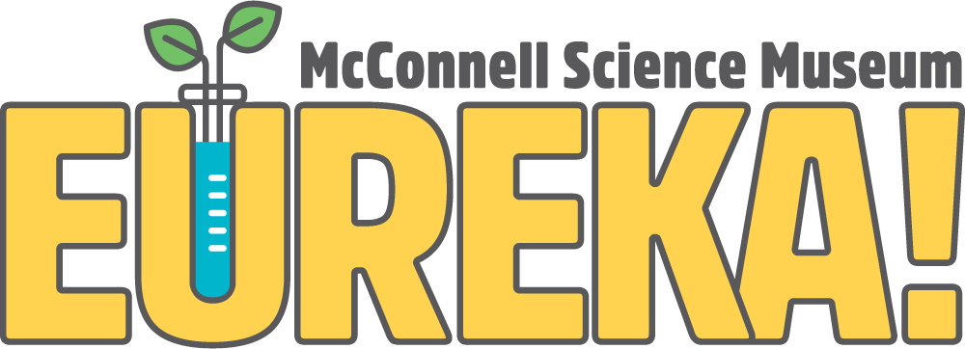
1400 N. 7th Street Grand Junction, CO 81501
Phone (970) 254-1626
eurekasciencemuseum.org

Environmental Institute Instructor Application

The EUREKA! McConnell Science Museum is seeking a highly qualified outdoor education instructor to work as part of the EUREKA! Environmental Institute team.

Please complete the application and return it along with your resume to:
Austin Solko
Operations Director
asolko@eurekasciencemuseum.org

Adam Bavier
Environmental Institute Director
abavier@eurekasciencemuseum.org

Instructions:
Please type out the information requested. For each question, type as much or as little as you feel necessary. If you have never been to EUREKA!, please visit our website: eurekasciencemuseum.org. Upon review of your application we will contact you.

Information:
Name:
Phone:
Email:

Questions:
- Why do you want to be an Environmental Institute Instructor at EUREKA!?

- Please list two of your strengths and one of your weaknesses.

- Briefly describe any experience you have working with or teaching children, young adults, adults, and seniors.

- Briefly describe any experience you have teaching science-based outdoor recreation and learning.

- What is your geographic familiarity with Colorado and the Western U.S.?

- What experience do you have with Microsoft Office? (Word and Excel)

- What outdoor activities would you be most excited to do with students? What science concepts are your favorites to teach?

- Why do you love field instruction? Please share a momentous outdoor adventure that you have taken that helped you learn you love to be outdoors.

- Please list any relevant certifications that you have completed (CPR/First Aid, WFR/WFA, Lifeguard, Rock Climbing, etc.…)

- Would you be willing to consider other related job offers for different positions at the EUREKA! McConnell Science Museum?

Yes No

