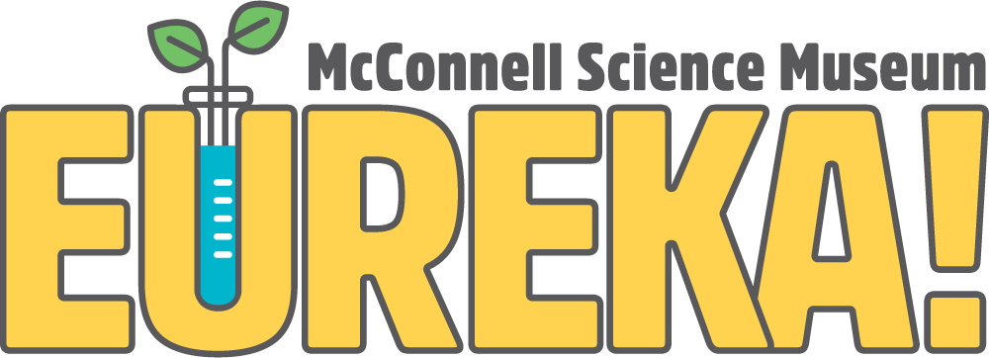
1400 N. 7th Street Grand Junction, CO 81501
Phone (970) 254-1626
eurekasciencemuseum.org

Afterschool Site Supervisor Application

The EUREKA! McConnell Science Museum is seeking Site Supervisors.

Please complete the application and return it along with your resume to:
Austin Solko
Operations Director
asolko@eurekasciencemuseum.org

Instructions:
Please type out the information requested. For each question, type as much or as little as you feel necessary. If you have never been to EUREKA!, please visit our website: eurekasciencemuseum.org. Upon review of your application we will contact you.

Information:
Name: Degree(s):
Phone:
Email:

Questions:
- Why do you want to be a site supervisor with EUREKA!?

- What are your strengths as an employee?

- How will this position help further your professional goals?

- What is your availability (please list available times):
Monday Friday
Tuesday Saturday
Wednesday Sunday
Thursday
How many total hours per week are you willing to commit to working at EUREKA!?

Comments:

- Briefly describe any experience you have working with or teaching elementary or middle school children.

- Do you have any work experience in any area of STEAM and/or Physical Education? If so, please describe briefly.

- Tell us something about yourself; hobbies or interests you might have

