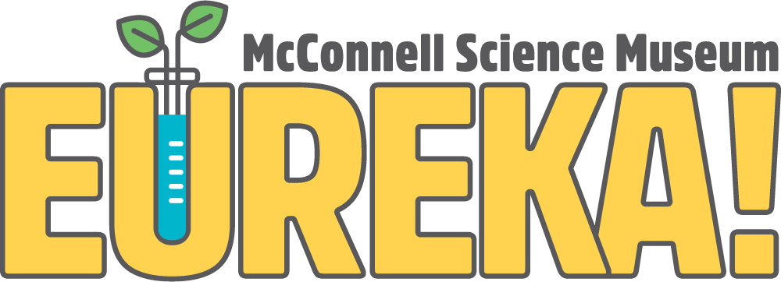
1400 N. 7th Street Grand Junction, CO 81501
Phone (970) 254-1626
eurekasciencemuseum.org

Environmental Institute Expedition Director Application

The EUREKA! McConnell Science Museum is seeking a highly qualified outdoor education director to work as part of the EUREKA! administration team.

Please complete the application and return it along with your resume to:
Austin Solko
Intern Director
asolko@eurekasciencemuseum.org

Instructions:
Please type out the information requested. For each question, type as much or as little as you feel necessary. If you have never been to EUREKA!, please visit our website: eurekasciencemuseum.org. Upon review of your application we will contact you.

Information:
Name:
Phone:
Email:

Questions:
- Why do you want to be the Environmental Institute Expedition Director at EUREKA!?

- Please list two of your strengths and one of your weaknesses.

- What is your personal mission statement?

- Do you see yourself as more introverted or extroverted?

- Briefly describe any experience you have working with or teaching children, young adults, adults, and seniors.

- Briefly describe any experience you have teaching science-based outdoor recreation and learning.

- What is your geographic familiarity with Colorado and the Western U.S.?

- What experience do you have with Microsoft Office? (Word and Excel)

- Would you be willing to consider other related job offers for different positions at the EUREKA! McConnell Science Museum?

Yes No

- Prepare a 5 day expedition camp for 10 physically average high-schoolers. You will be departing from and returning in Grand Junction, and will have one additional staff member with you. You will be taking one van with a trailer for supplies. Be sure to include a rough draft itinerary, which locations you will visit, what activities you will do, and anything else you think is important (attach any extra documents along with this one if applicable).
- Please list the ten most momentous outdoor adventure trips that you have taken that would best pertain to the Environmental Institute Expedition Director position
Location – Where did you go for this trip? | Duration – How long did you stay at each location? | Activities – e.g. rafting, climbing, snowshoeing, hiking, camping, biking, fishing, backpacking, etc… | Reason – e.g. personal, professional, guide leader, etc… | Teaching – Did you teach any curriculum on this trip? If so, what content and age group?

