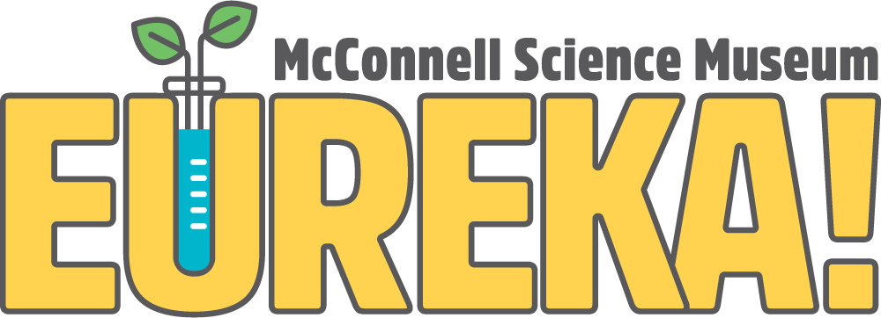
1400 N. 7th Street Grand Junction, CO 81501
Phone (970) 254-1626
eurekasciencemuseum.org

STEAM Intern Application

The EUREKA! McConnell Science Museum is seeking undergraduate science, engineering, education, or math students to work as part of the STEAM Intern team.

Please complete the application and return it along with your resume, school schedule, and transcripts (unofficial is okay) to:
Austin Solko
Operations Director
asolko@eurekasciencemuseum.org

Instructions:
Please type out the information requested. For each question, type as much or as little as you feel necessary. If you have never been to EUREKA!, please visit our website: eurekasciencemuseum.org. Upon review of your application we will contact you.

Information:
Name: Phone:
School: Major(s):
Expected Graduation Date (month/year):

Questions:
- Why do you want to be a STEAM Intern at EUREKA!?

- What are your strengths as an employee?

- How will this position help further your educational goals?

- What is your availability (please list available times):
Monday Friday
Tuesday Saturday
Wednesday Sunday
Thursday
How many total hours per week are you willing to commit to working at EUREKA!?

Comments:

- Briefly describe any experience you have working with or teaching elementary or middle school children.

- Do you have any work experience in any area of science or engineering? If so, please describe briefly.

- Tell us something about yourself; hobbies or interests you might have.

